TECHNICAL DATA SHEET

Sparco Weather Shelter
SPARCO
PAINTS

Roller
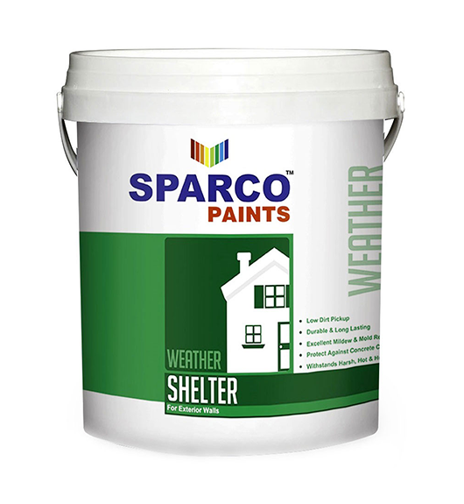

Packing Size
1,4, 16 Ltr.

Handling
Handle with care, stir well before use

Storage
The product must be stored in accordance with national regulations. Storage conditions are to keep the containers in a dry, cool, well ventilated space and away from source of heat and ignition. Containers must be kept tightly closed.

Health and Safety
Please observe the precautionary notices displayed on the container. Use under well ventilated conditions. Do not breathe or inhale mist. Avoid skin contact. Spillage on the skin should immediately be removed with suitable cleanser, soap and water. Eyes should be well flushed with water and medical attention sought immediately. For detailed information on the health and safety hazards and precautions for use of this product, we refer to the Material Safety Data Sheet.

Typical Paint System
Sparco Water based Primer 1-2 Coat Sparco Wall Putty 1-2 Coat
Sparco Weather Shelter 2 Coats

Product Description
Sparco Weather Shelter is a 100% pure acrylic based paint specially formulated to with stand the harsh, hot and humid climate of subcontinent. The special acrylic binder gives a durable and long lasting matt finish with low dirt pickup. Sparco Weather Shelter special formulation will also protect against concrete carbonation. It is ideal for decorating and protecting exterior surfaces and specially suited as a maintenance product.

Recommended Use
Recommended for use on most exterior as well as interior surfaces onto concrete, cement, plaster, gypsum, brick work & asbestos substrates. It can also be used as topcoat on other emulsion based paints, for textured, rough textured and graffito systems.

Film thickness and Spreading Rate
Dry film thickness 25-30 microns
Wet film thickness 65-70 microns
Theoretical Spreading Rate 15-17 m2/litr/coat

Physical Properties
Colour As per Shade Card
Finish Matt Solids volume % 45 ± 2
Flash Point N.A
Specific Gravity 1.40-1.60

Surface Preparation
The substrate must be sound, clean, dry, free from dust, oil and grease etc. it can be either pre-primed or smooth surface. All traces of release agents must be removed. On chalky and dusty surfaces, all loose material must be removed by stiff bristle brushing.
Application methods

TT^ &
I'Spray (f Brush

Drying Time
Temperature | Touch Dry | Recoating  Interval | Hard Dry
23 °C | 40 min | 4 hours | 6 Hours
30 °C | 30 min | hours | 4 hours
38 °C | 20 min | 2 hours | 2 Hours

Application Data
System | Single component System
Thinner | Clean water
Thinning Hfrtfe % | 60-70

DISCLAIMER
The information in this data sheet is given to the best of our knowledge based on laboratory testing and practical experience. However, as the product can be used under conditions beyond our control, we can only guarantee the quality of the product itself We also reserve the right to change the given data without notice.

